Nagarjuna College of Engineering & Technology
(An Autonomous college under VTU)
Department of Mechanical Engineering

Faculty Development Programme
Course : Mechanical engineering foundation Lab (I C)
Course Code : 15MEF14/24
Venue : Room No 104
Date : 20th June and 24th June 2016.
Introduction : Dr.N.Kapilan, HOD (Mechanical ) gave the introduction to Faculty Development Programme and highlighted the need and importance of the FDP. Both teaching and non-teaching staff of the department have attended this FDP.
Dr N Kapilan :
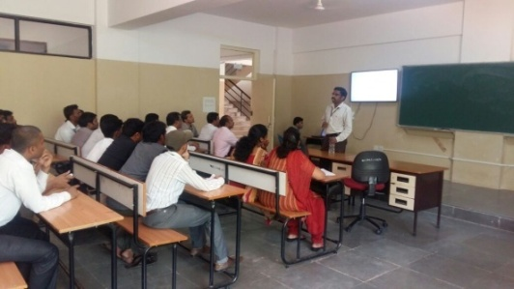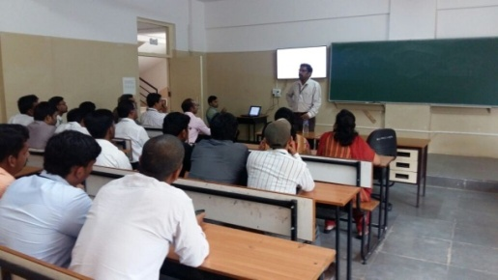

Experiment : 1)Demonstration of Fitting Tools & 2) Photo Voltaic Cell
Faculty : V A Kulkarni
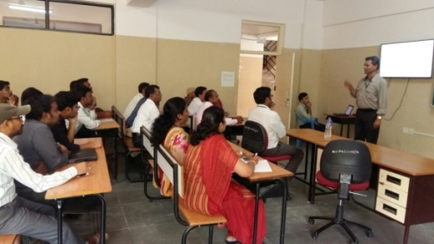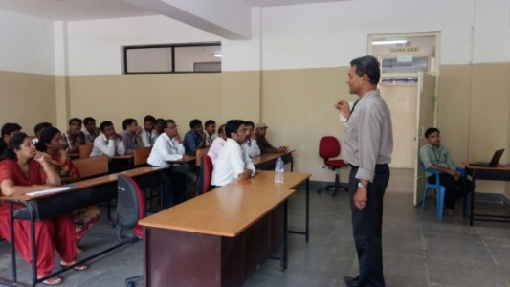
Demonstration of Fitting Tools Photo Voltaic Cells

3)Experiment : Robot Programing
Faculty : Bandoli Siddesh Iresh
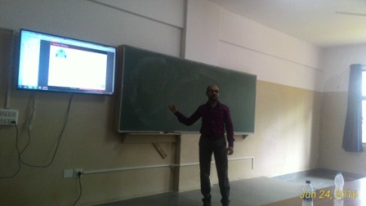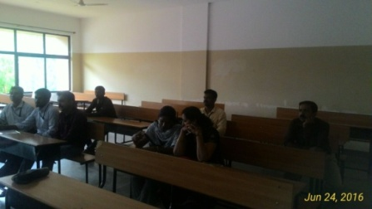
Robot Programming
4)Experiment : Demonstration of Joining Process & 5) Joining process by Soldering
Faculty : Balaji Y V
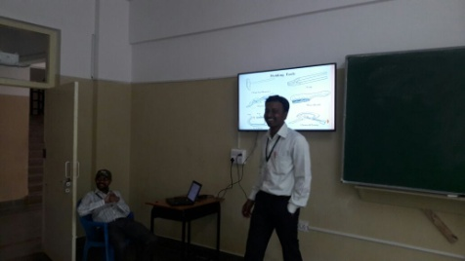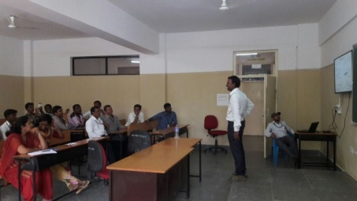
Demonstration of Joining Process Joining process by Soldering
6) Experiment : Sheet Metal Development of 1)Hexogonal Prism 2) Square Pyramid
Faculty : Julya Naik
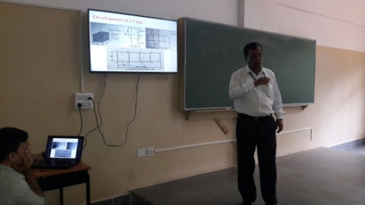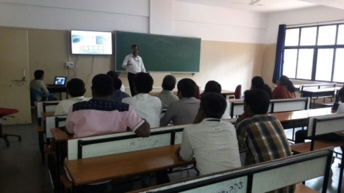
Hexogonal Prism Square Pyramid
7) Vapour Compression Refrigeration System & 8) Water Turbines
Faculty : Manjunath R 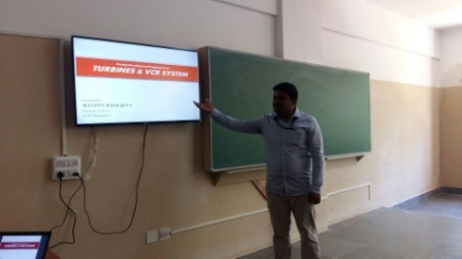 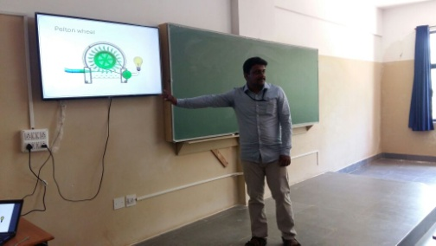
Vapour compression refrigeration system Water turbines
9)Experiment: Valve and Port Diagrams & 10) Simple Gear Drive
Faculty : Sandya P S

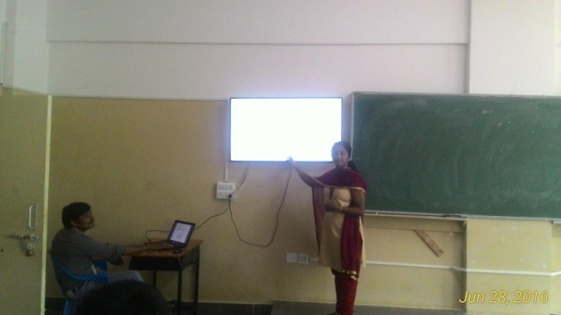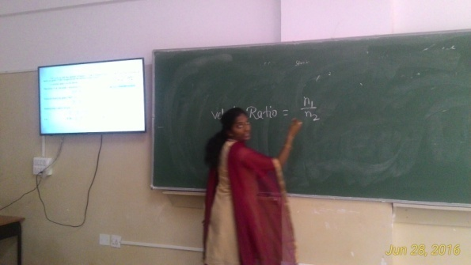
Valve and Port Diagrams Simple Gear Drive

---------------------------------------------------------------------------------------------------------------------------

