Nagarjuna College of Engineering & Technology
(An Autonomous college under VTU)
Department of Mechanical Engineering

Faculty Development Programme
Course : Manufacturing Process Laboratory

Course Code : 15MEL37
Venue : Manufacturing Process lab (Foundry Lab)
Date : 30th June and 1stJuly 2016.
Introduction : Dr.N.Kapilan, HOD (Dept of Mechanical Engg ) gave the introduction to Faculty Development Programme and highlighted the need and importance of the FDP. Both teaching and non-teaching staff of the department have attended this FDP.
Dr N Kapilan, HOD, Mechanical Engg :
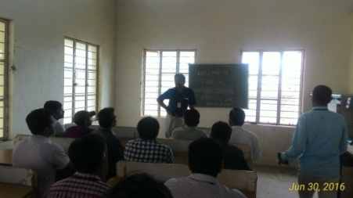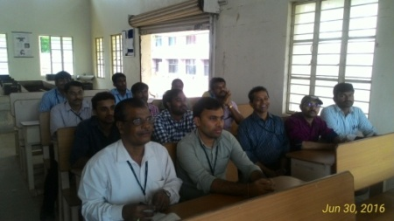

Experiment : 1)Clay Content Test & 2) Permeability Test
Faculty : V A Kulkarni
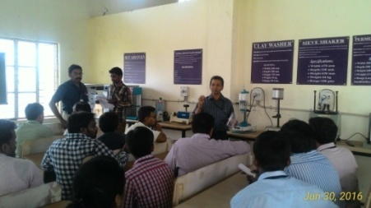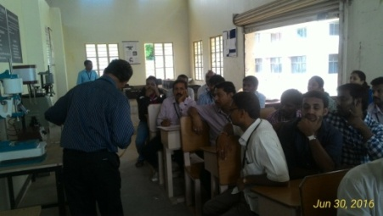
Clay Content Test Permeability Test

3)Experiment :Sieve Shaker Test
Faculty : G.D Mohan Kumar
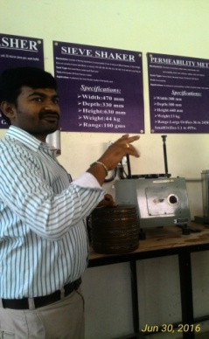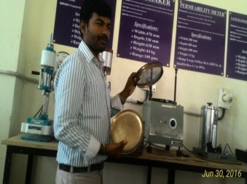
Sieve Shaker Test

4)Experiment : Green Compression Strength & 5) Shear Strength
Faculty : Bandoli Siddeshwar Iresh
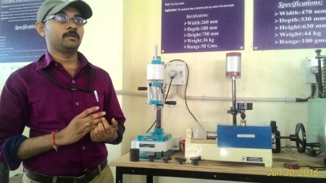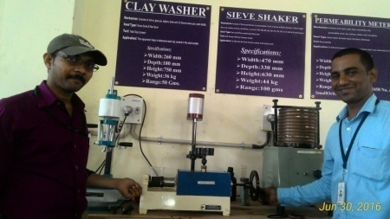
Green Compression Strength Shear Strength

6) Experiment : Foundry Practice
Faculty : V A Kulkarni
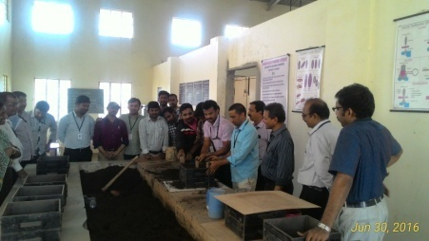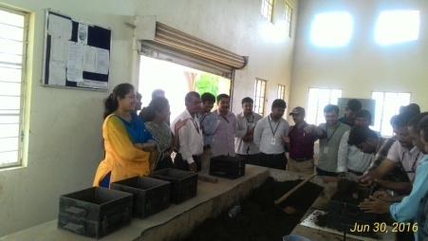
Foundry Practice

6)Welding Practice
Faculty : L J Naik 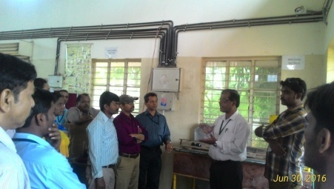 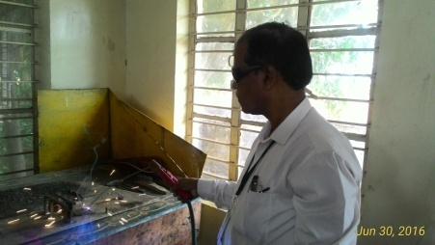
Welding Practice

Power Point Presentation of Experiments by Faculties
Demonstration of Welding Joining Process Demonstration of Permeability Test
Faculty : L J Naik Faculty : V A Kulkarni

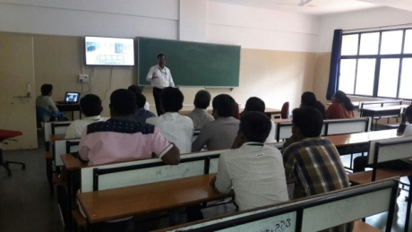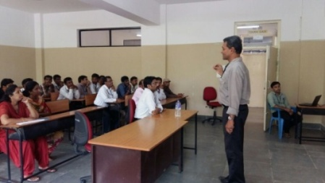

Foundry Sand Strength
Faculty : Bandoli Siddeshwar Iresh

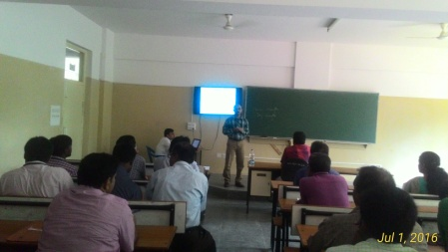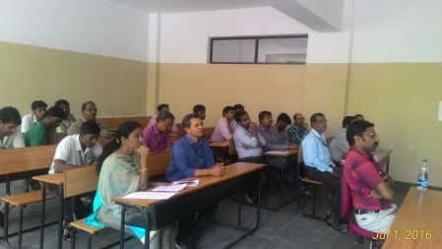

Grain Fineness Test , Sieve Analysis of Sand
Faculty : G.D Mohan Kumar

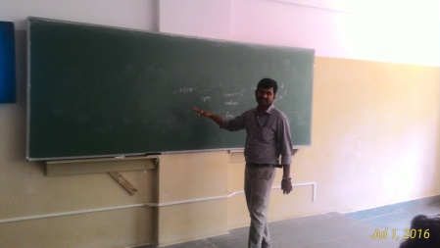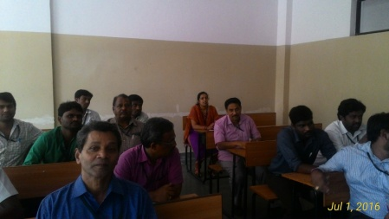

Preparation of Mould using Split Pattern 3D Printing
Faculty : Vinod Kumar R Faculty : Anand Babu K




